**FIT – Lisbon & Porto**

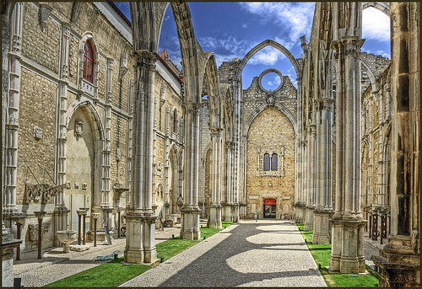 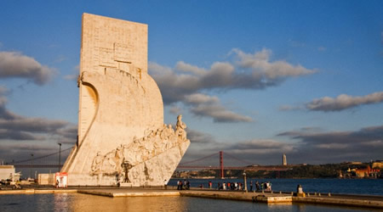 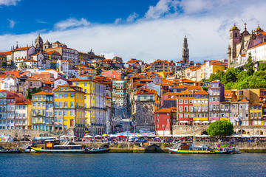

**day 1 Lisbon**

**private transfer** from **Lisbon** airport to the hotel in the city.

**Lisbon sightseeing** based on a hop on hop off bus.

* *the* ***Alfama quarter*** *is the oldest quarter in Lisbon.*
* ***Belem Tower*** *is a fortified tower declared a UNESCO world heritage site because of the significant role it played in the Portuguese maritime discoveries throughout the years.*
* ***the Jerónimos******Monastery*** *this magnificent monastery, a world heritage site since 1983, is one of the most successful achievements of the Manueline style.*

overnight at hotel in Lisbon.

**day 2 Lisbon**

breakfast at the hotel.

**full day Sintra and Cascais** excursion on regular basis.

***Sintra*** *is located 30 km from Lisbon. in 1995 the town of Sintra was classified as a world heritage site, with architectural monuments that stand out such as the* ***Town Palace****, the* ***Pena Palace*** *and the* ***Moorish Castle****.*

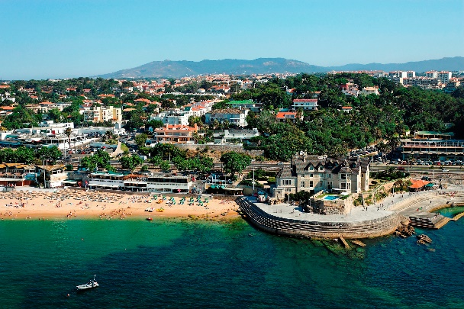

***Cascais*** *is a former fishing village situated in the southern region of Portugal, where visitors can enjoy its picturesque architecture. return* *to Lisbon along the coast, passing by* ***Estoril,*** *admiring the beautiful coast and it’s beaches.*

overnight at hotel in Lisbon.

**day 3 Lisbon**

breakfast at the hotel.

**day at leisure.**

*Lisbon is one of the oldest cities in the world, and the oldest in Western Europe, predating other modern European capitals such as London, Paris and Rome by centuries.*

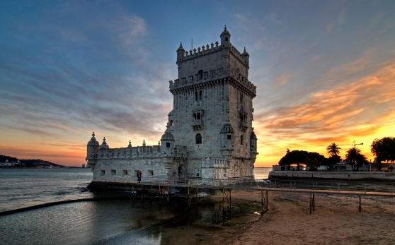

overnight at hotel in Lisbon.

**day 4 Lisbon - Porto**

breakfast at the hotel and check out.

**private transfer** to Lisbon train station to take the train to **Porto**.   
**private transfer** from Porto train station to the hotel.

afternoon at leisure to discover the city.

overnight at hotel in Porto.

**day 5 Porto**

breakfast at the hotel.

**Porto sightseeing** based on a hop on- hop off bus.

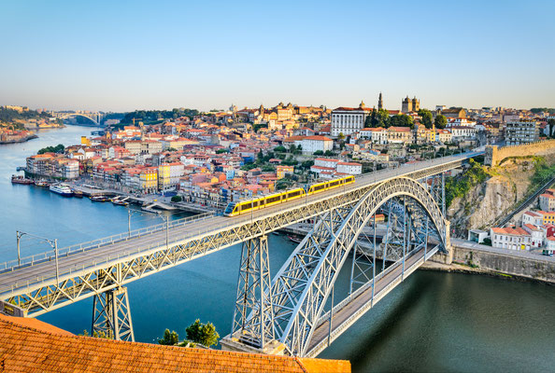

*Porto is the second largest city in Portugal. the history of Porto dates back to the 4th century, to the roman occupation of the Iberian peninsula, although Celtic and Proto-Celtic ruins have been discovered in several areas. the charm and character of its old quarters filled with cafes and shopping centres is matched by the cathedral area, perfect for exploring. the civic centre of the city in the central Baixa quarter with broad avenues lined with banks and outdoor cafes, not forgetting the two-tiered covered daily market.*

overnight at hotel in Porto.

**day 6 Porto**

breakfast at the hotel.

full day **excursion to wine region** and winery visit.

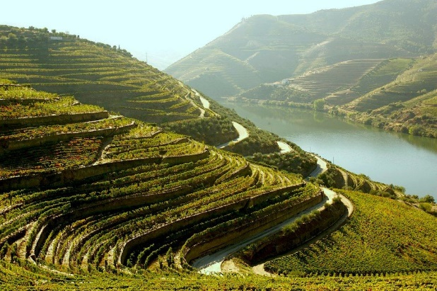

*the tour starts with a panoramic visit to the historic centre and riverside. it will take you towards Régua to visit the town centre and learn more about vineyards and wines while enjoying a wine tasting at a Port Wine Estate. during the tour you will discover the small town of Pinhão and visit the Vila Real’s historic centre for a panoramic view.*

*Port wine (Vinho do Porto in Portuguese) is a Portuguese fortified wine produced exclusively in the Douro Valley in the northern provinces of Portugal. it is typically a sweet, red wine, often served as a dessert wine, though it also comes in dry, semi-dry, and white varieties.*

overnight at hotel in Porto.

**day 7 Porto**

breakfast at the hotel and check out.

**private departure transfer** to Porto airport.

**end of services**

**prices**

|  |  |  |  |
| --- | --- | --- | --- |
| **price per person & package** | **Nov - Mar** | **Apr – Oct** | **Jul - Aug** |
| **standard class** | **525 €** | **595 €** | **630 €** |
| child standard price (up to 11 yrs) | **200 €** | **200 €** | **200€** |
| single supplement | **185 €** | **237 €** | **275 €** |
| **first class** | **585 €** | **745 €** | **699 €** |
| child first price (up to 12 yrs) | **190 €** | **190 €** | **190 €** |
| single supplement | **221 €** | **355 €** | **320 €** |
| **superior class** | **665 €** | **886 €** | **820 €** |
| child superior price (up to 12 yrs) | **130 €** | **130 €** | **130 €** |
| single supplement | **310 €** | **504 €** | **403 €** |

\* prices per person based on double room & bb basis. taxes included. valid for minimum 2 traveling pax.

\* prices subject to availability and possible fluctuations in any of the requested services at the time of final booking.

**validity**: **until October 2020.**

**inclusions:**

|  |  |  |  |  |
| --- | --- | --- | --- | --- |
| **city & nights** | **transfers** | **sightseeing on SIC basis** | **meals** | **24h. phone assistance** |
| **3n Lisbon** | transfer apt-htl-station | hop on hop off bus  full day Sintra & Cascais excursion | breakfast |
| **3n Porto** | transfer station-htl-apt | hop on hop off bus  full day wine region excursion, including wine tasting at winery | breakfast |

price does not include:

* regional tourist tax.
* tips and guests’ extras.
* any other service not mentioned on the programme/ itinerary described.
* train tickets, please find supplement below:
  + *AP high speed train Lisbon – Porto:  
    per person on tourist class:* ***from 32,30 €*** *(+ 4% handling fee)*
* **transportation to sightseeing meeting points is not included, we recommend the use of public transportation or taxi.**

**optional supplements**:

|  |  |  |
| --- | --- | --- |
| C:\Users\marketing2\Downloads\fado-A.jpg  **fado show & dinner**  adult: from 43 €  (vegetarian menu and children menus available) | C:\Users\marketing2\Downloads\2_575.jpg  **Lisbon by boat**  adults: 35 € children: 18 € | C:\Users\marketing2\Downloads\fatima-round-trip-A.jpg  **full day Fatima excursion from Lisbon on SIC basis**  adults: 85 € |
| C:\Users\marketing2\Downloads\Header-Porto.jpg  **Porto by boat**  adults: 15 € children: 8 € |  |  |

\*price per person

**itinerary & number of nights**

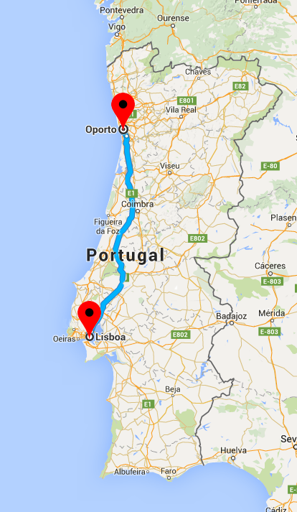

**3n**

**Lisbon**

**3n**

**Porto**